Lagged cross-correlation: NZDUSD and USDJPY
Method 12 / daily log returns / K_max=10 / Alpari D1 full available history

Study setup
Logical pair: NZDUSD , USDJPY
Broker symbols: NZDUSD_i , USDJPY_i
Snapshot: 2026-11-03_majors_alpari_D1
Timeframe: D1
Matched return window: 1999-01-05 to 2026-11-02 (UTC bar dates)
Matched return count n: 7185
Dropped unfinished last bar dated 2026-11-03 UTC after a tick-volume check against the prior complete day.
Lag definition: rho_X->Y(k) = Corr(x_t, y_{t+k}) on matched D1 bars
K_max = 10; headline lag k = 1 (both directions)
Complete matched rows (Excel): NZDUSD-USDJPY_Lagged_D1.xlsx
Complete matched rows (HTML table): NZDUSD-USDJPY_Lagged_D1_data.html

Method carried forward
Lagged cross-correlation measures Pearson correlation between matched daily log returns of close, ln(close_t / close_t-1), after shifting one series forward by k bars on the matched panel. Quotes are not inverted. rho_{X->Y}(k) = Corr(x_t, y_{t+k}) with n_k = n - k. K_max = 10 is fixed before estimation. The headline is the pre-specified lag k = 1 in both directions. k = 0 is the same-bar side check. The lag inside 1..10 with the largest absolute rho is stored as a descriptive column only; it is not a selected result. This is a linear screen, not proof of forecast edge, economic cause, or a trading signal.

Results (headline k=1)
rho_NZDUSD->USDJPY(1): -0.035402 (n=7184)
95% Fisher interval NZDUSD->USDJPY: [-0.058478, -0.012287]
rho_USDJPY->NZDUSD(1): 0.008795 (n=7184)
95% Fisher interval USDJPY->NZDUSD: [-0.014333, 0.031913]
Same-bar rho(k=0): -0.133568
Largest |rho| among k=1..10 (descriptive only, not selected): NZDUSD->USDJPY k=1 rho=-0.035402; USDJPY->NZDUSD k=6 rho=-0.025986

CCF table
k | rho_NZDUSD_to_USDJPY | n_NZDUSD_to_USDJPY | rho_USDJPY_to_NZDUSD | n_USDJPY_to_NZDUSD
0 | -0.13356845 | 7185 | -0.13356845 | 7185
1 | -0.03540152 | 7184 | 0.00879503 | 7184
2 | 0.00157597 | 7183 | 0.01127416 | 7183
3 | -0.00438346 | 7182 | 0.01295344 | 7182
4 | -0.00940329 | 7181 | -0.00239843 | 7181
5 | 0.00951947 | 7180 | 0.00827847 | 7180
6 | -0.00594398 | 7179 | -0.02598578 | 7179
7 | -0.00163682 | 7178 | 0.0022618 | 7178
8 | 0.01691739 | 7177 | -0.01361924 | 7177
9 | -0.01441399 | 7176 | -0.01941219 | 7176
10 | -0.00198241 | 7175 | -0.00679192 | 7175

Conclusion
At the pre-specified lag k=1 for NZDUSD and USDJPY, rho_{NZDUSD->USDJPY}(1) = -0.0354 (n=7184) and rho_{USDJPY->NZDUSD}(1) = 0.0088 (n=7184). Same-bar rho(k=0) = -0.1336. Largest |rho| among k=1..10 is descriptive only: NZDUSD->USDJPY at k=1 (-0.0354); USDJPY->NZDUSD at k=6 (-0.0260). This is a linear screen, not forecast proof or a trading signal.

Charts
Daily closes

Daily log returns

CCF both directions k=0..10
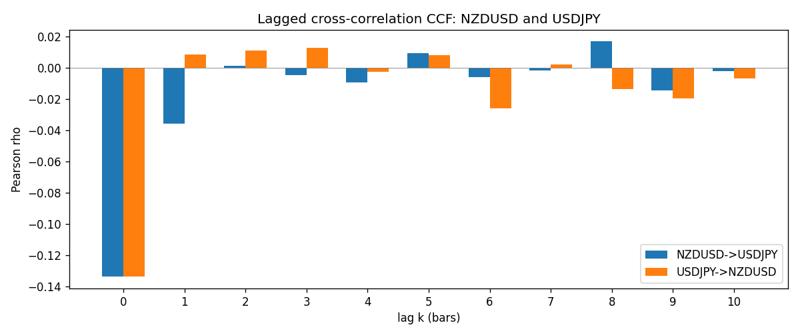

Data report
Every matched row is stored in the sibling Excel workbook named NZDUSD-USDJPY_Lagged_D1.xlsx (sheet matched_rows). The CCF sheet holds rho(k) for k=0..10. Embedding all rows as a Word table is impractical; the Word file holds column summaries and the first and last 15 rows.
Columns: time, NZDUSD_open, USDJPY_open, NZDUSD_high, USDJPY_high, NZDUSD_low, USDJPY_low, NZDUSD_close, USDJPY_close, NZDUSD_tick_volume, USDJPY_tick_volume, NZDUSD_spread, USDJPY_spread, NZDUSD_real_volume, USDJPY_real_volume, NZDUSD_log_return, USDJPY_log_return
Column summaries (matched calculation rows)
column | count | mean | std | min | 25% | 50% | 75% | max
NZDUSD_open | 7185 | 0.65641035 | 0.10820414 | 0.3913 | 0.59133 | 0.6684 | 0.72491 | 0.88218
USDJPY_open | 7185 | 113.80829 | 19.224285 | 75.693 | 104.39 | 110.98 | 120.695 | 163.824
NZDUSD_high | 7185 | 0.6603272 | 0.1086977 | 0.3961 | 0.59474 | 0.672 | 0.72936 | 0.88421
USDJPY_high | 7185 | 114.30556 | 19.28576 | 76.001 | 104.868 | 111.439 | 121.26 | 163.978
NZDUSD_low | 7185 | 0.65272421 | 0.10779902 | 0.3897 | 0.58806 | 0.66417 | 0.72098 | 0.87988
USDJPY_low | 7185 | 113.28523 | 19.152023 | 75.402 | 103.88 | 110.53 | 120.17 | 163.628
NZDUSD_close | 7185 | 0.65648647 | 0.10820164 | 0.3907 | 0.59157 | 0.6684 | 0.72502 | 0.8822
USDJPY_close | 7185 | 113.8211 | 19.239467 | 75.811 | 104.38 | 111.015 | 120.69 | 163.851
NZDUSD_tick_volume | 7185 | 68717.699 | 123140.61 | 16 | 5585 | 33899 | 58511 | 1127682
USDJPY_tick_volume | 7185 | 106344.18 | 179438.14 | 149 | 9948 | 53202 | 92889 | 1803508
NZDUSD_spread | 7185 | 30.280167 | 25.649381 | 0 | 9 | 17 | 40 | 80
USDJPY_spread | 7185 | 20.273626 | 17.623751 | 0 | 6 | 11 | 30 | 50
NZDUSD_real_volume | 7185 | 1.6703703e+10 | 8.4983725e+10 | 0 | 0 | 0 | 0 | 2.705649e+12
USDJPY_real_volume | 7185 | 3.4781051e+10 | 1.6093614e+11 | 0 | 0 | 0 | 0 | 3.8834203e+12
NZDUSD_log_return | 7185 | 1.284e-05 | 0.0076404 | -0.07027433 | -0.00425236 | 0.00022967 | 0.00458145 | 0.05966839
USDJPY_log_return | 7185 | 4.789e-05 | 0.00620418 | -0.03908203 | -0.00320044 | 0.00011802 | 0.00340223 | 0.05184024
First 15 matched rows (selected columns)
time | NZDUSD_close | USDJPY_close | NZDUSD_log_return | USDJPY_log_return
1999-01-05 | 0.5372 | 111.92 | -0.0018597736 | -0.00017868311
1999-01-06 | 0.5383 | 112.77 | 0.0020455609 | 0.0075660159
1999-01-07 | 0.5417 | 111.33 | 0.0062963171 | -0.012851583
1999-01-08 | 0.5414 | 110.8 | -0.00055396548 | -0.0047719894
1999-01-11 | 0.547 | 109.02 | 0.010290425 | -0.016195423
1999-01-12 | 0.5441 | 112.6 | -0.0053157489 | 0.032310364
1999-01-13 | 0.5387 | 113.52 | -0.0099742238 | 0.0081373171
1999-01-14 | 0.5386 | 113.52 | -0.00018564931 | 0
1999-01-15 | 0.5382 | 114.15 | -0.00074294208 | 0.0055343401
1999-01-18 | 0.5372 | 114.16 | -0.0018597736 | 8.7600193e-05
1999-01-19 | 0.5382 | 113.52 | 0.0018597736 | -0.0056219403
1999-01-20 | 0.5404 | 112.91 | 0.0040793678 | -0.0053879917
1999-01-21 | 0.5426 | 113.87 | 0.0040627941 | 0.0084664056
1999-01-22 | 0.5361 | 114.56 | -0.012051689 | 0.0060412564
1999-01-25 | 0.5342 | 113.72 | -0.0035504102 | -0.0073594164
Last 15 matched rows (selected columns)
time | NZDUSD_close | USDJPY_close | NZDUSD_log_return | USDJPY_log_return
2026-10-13 | 0.56127 | 158.305 | 0.0047326165 | -0.0018932826
2026-10-14 | 0.55918 | 158.317 | -0.0037306483 | 7.5800166e-05
2026-10-15 | 0.56185 | 158.024 | 0.0047634855 | -0.0018524319
2026-10-16 | 0.56509 | 157.964 | 0.0057501001 | -0.00037976126
2026-10-19 | 0.56616 | 158.517 | 0.0018917133 | 0.0034946841
2026-10-20 | 0.56827 | 158.16 | 0.0037199341 | -0.0022546642
2026-10-21 | 0.57003 | 158.108 | 0.0030923331 | -0.00032883504
2026-10-22 | 0.56815 | 156.755 | -0.0033035227 | -0.0085942669
2026-10-23 | 0.56991 | 156.81 | 0.0030929853 | 0.00035080446
2026-10-26 | 0.56826 | 157.458 | -0.0028993932 | 0.0041238746
2026-10-27 | 0.56811 | 157.894 | -0.00026399852 | 0.0027651658
2026-10-28 | 0.56261 | 157.743 | -0.0097283914 | -0.00095679538
2026-10-29 | 0.56296 | 157.683 | 0.00062190714 | -0.00038043789
2026-10-30 | 0.56307 | 157.516 | 0.00019537668 | -0.0010596481
2026-11-02 | 0.56161 | 157.933 | -0.0025962955 | 0.0026438521

